Package Manager
# Source: AI Source: Provided by: [Data Path: Persons Table -> ID Column: 1, Name_En Column: Motasem Essam] -> From: [Chatgpt (GPT‑5 Mini)] on [1/26/2026]
A package manager is a tool that automates the process of installing, upgrading, configuring, and removing software packages on your computer.
A software package is a bundle of related programs, libraries, and files that are grouped together and installed as one unit to perform a specific task or set of tasks.

🔧 What a Package Manager Does:
# Source: AI Source: Provided by: [Data Path: Persons Table -> ID Column: 1, Name_En Column: Motasem Essam] -> From: [Chatgpt (GPT‑5 Mini)] on [1/26/2026]
- Downloads software from trusted sources.
- Installs it with dependencies.
- Updates it to the latest version.
- Removes it cleanly.
- Often handles version conflicts and system compatibility.

🧱 Examples of Package Managers:

🪟 On Windows:
# Source: AI Source: Provided by: [Data Path: Persons Table -> ID Column: 1, Name_En Column: Motasem Essam] -> From: [Chatgpt (GPT‑5 Mini)] on [1/26/2026]
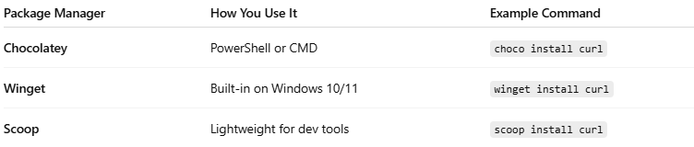

Package Manager | How You Use It | Example Command
Chocolatey | PowerShell or CMD | choco install curl
Winget | Built-in on Windows 10/11 | winget install curl
Scoop | Lightweight for dev tools | scoop install curl

🐧 On Linux:
# Source: AI Source: Provided by: [Data Path: Persons Table -> ID Column: 1, Name_En Column: Motasem Essam] -> From: [Chatgpt (GPT‑5 Mini)] on [1/26/2026]
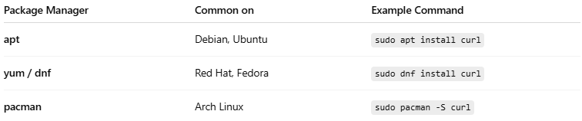

Package Manager | Common on | Example Command
apt | Debian, Ubuntu | sudo apt install curl
yum / dnf | Red Hat, Fedora | sudo dnf install curl
pacman | Arch Linux | sudo pacman -S curl

🍏 On macOS:
# Source: AI Source: Provided by: [Data Path: Persons Table -> ID Column: 1, Name_En Column: Motasem Essam] -> From: [Chatgpt (GPT‑5 Mini)] on [1/26/2026]

Package Manager | Example Command
Homebrew | brew install curl

🧠 Why It's Useful:
# Source: AI Source: Provided by: [Data Path: Persons Table -> ID Column: 1, Name_En Column: Motasem Essam] -> From: [Chatgpt (GPT‑5 Mini)] on [1/26/2026]
- No need to search for .exe files or go to websites.
- Automatically configures your system.
- Easy to update all software with a single command.
- Great for scripting or setting up environments quickly.

